# VIRTUALIZATION & CLOUD COMPUTING

## ASSIGNMENT

Create a kubernetes cluster and deploy a node js application on kubernetes. Expose it as a service. Create a replication controller and scale it to 3 nodes.

kubectl cluster-info

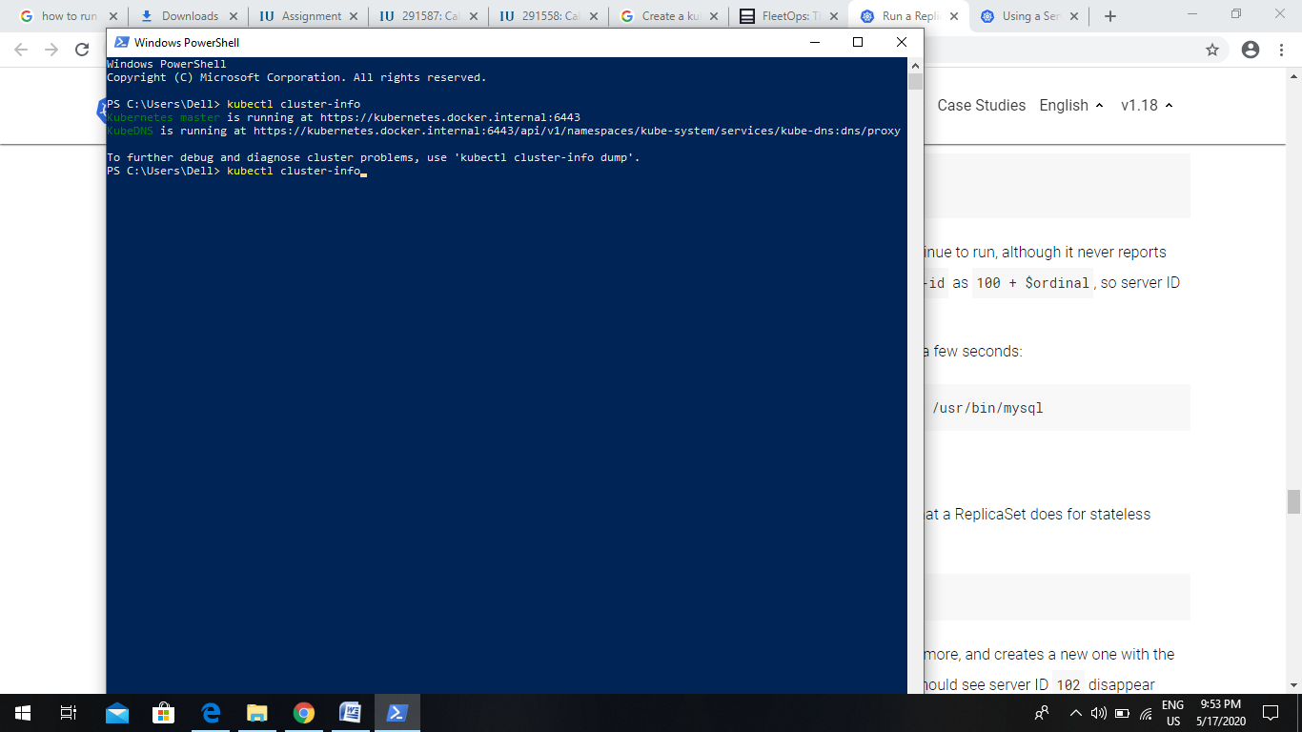

kubectl get nodes

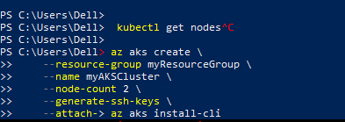

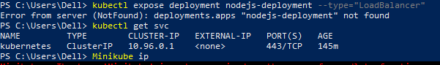

minikube start

This command will spin up the cluster, having one node that serves as a worker and one as a master node.

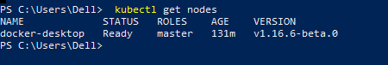

docker image ls

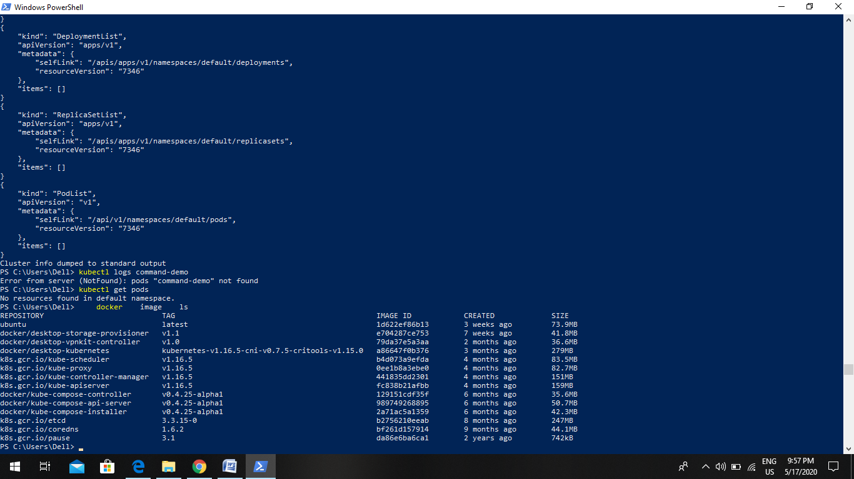

docker container run -it ubuntu:latest /bin/bash

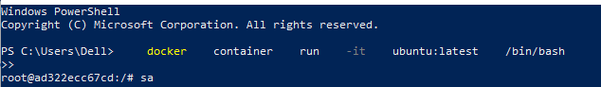

Deploy your application using the following command:

kubectl run kubia --image=luksa/kubia -- port=8080 --generator=run/v1

kubectl expose rc kubia -- type=LoadBalancer --name kubia-http

kubectl get services

Replication controllers

kubectl get replicationcontrollers

kubectl get rc  
 kubectl get pods

kubectl get pods -o wide

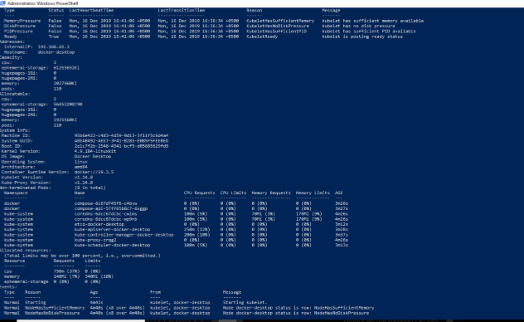

kubectl cluster-info dump

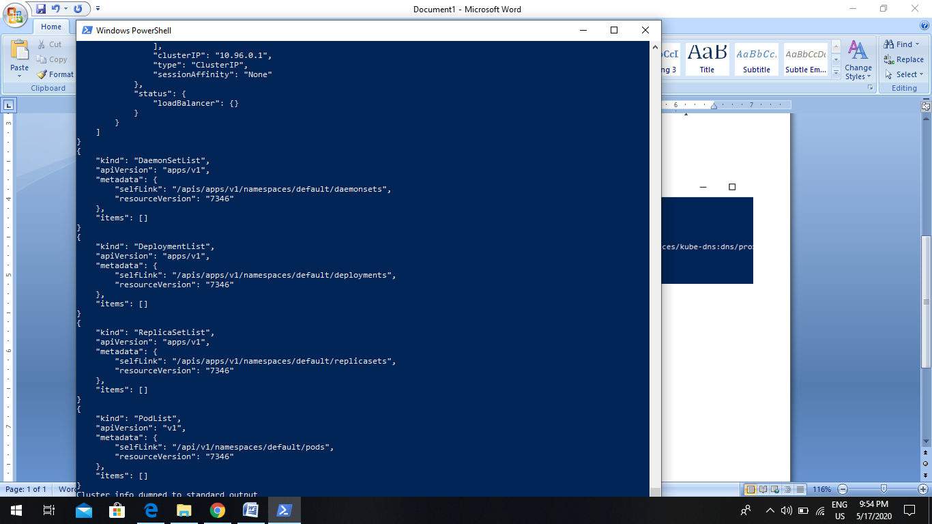

docker image pull

